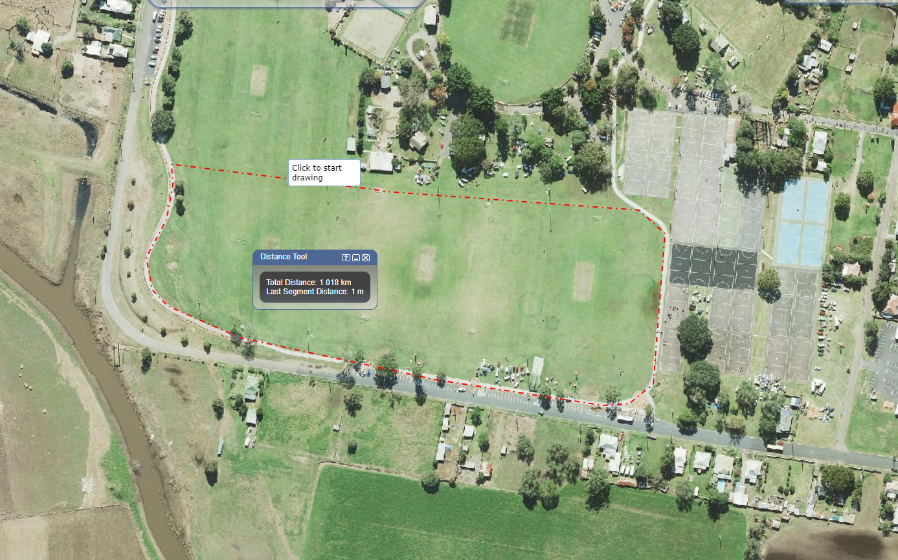
B/up TOILETS
MARSHALLING
Main TOILETS
All Saints Area
North Region Area
Manning Area
U/Hunter Area
Central Area
Lakes Area
BBQ
STAFF ONLY PARKING
Start/Finish Line

