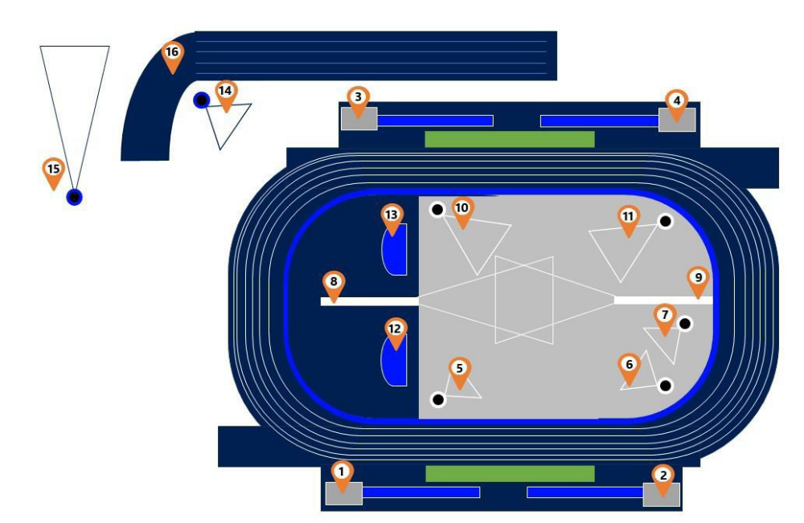
MARSHALLING
1. Triple Jump
10. Discus Girls
13.High Jump Girls

8. Javelin Boys
12.High Jump Boys

9. Javelin Girls
6. Shot Put Girls
11. Discus Boys
4. Long Jump Girls
3. Long Jump Boys
14. Shot Put Boys
16.Warm Up Track
CANTEEN
Entry/Exit to Facility via carpark gate ONLY
GRANDSTAND

SCT, SJL, SFX, SCS, TCC, SBC, ASC, TCC, SMG, CMM, SCM, SJA

