Congratulations to our 2024 champions -
Open Girls
Champions - Brigidine College, St Ives
Runner's Up - Stella Maris College, Manly
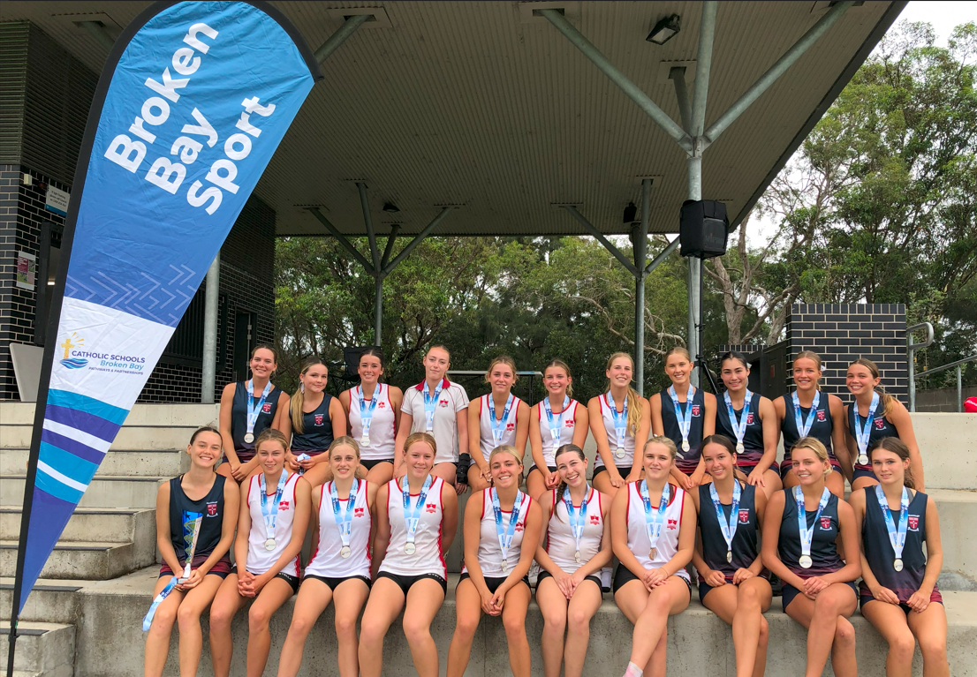
​
U15 Girls
Champions - Mount St Benedict College, Pennant Hills
Runner's Up - Stella Maris College, Manly
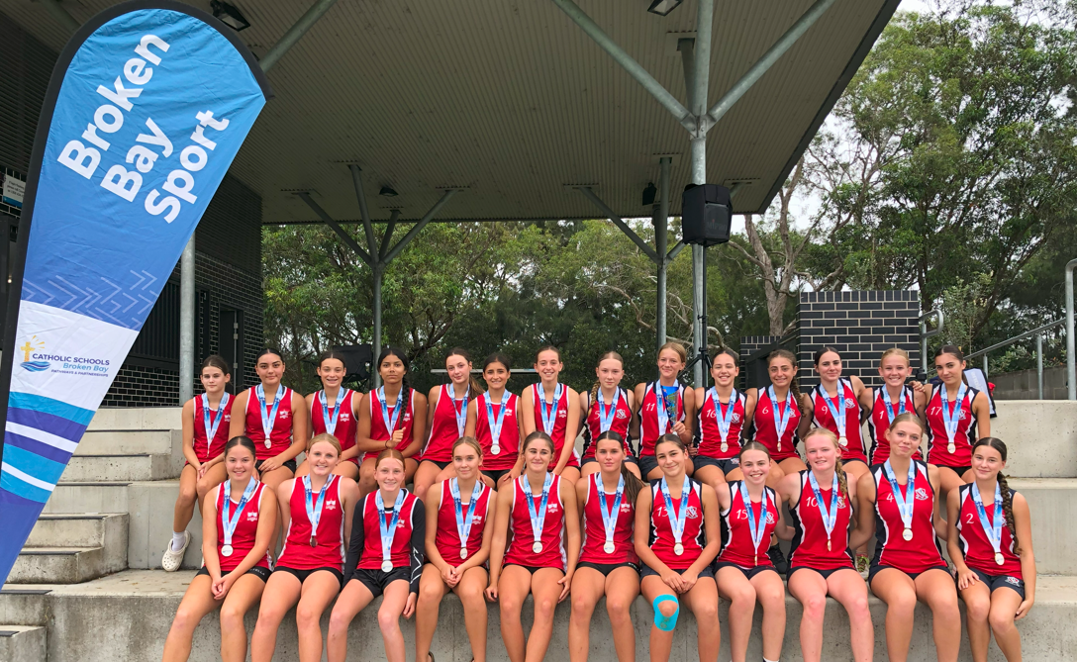

U13 Boys
Champions - Mater Maria Catholic College, Warriewood
Runner's Up - St Edward's College, Gosford
U13 Girls
Champions - Mount St Benedict's College, Pennant Hills
Runner's Up - St Brigid's Catholic College, Lake Munmorah

