Congratulations to our 2023 champions -

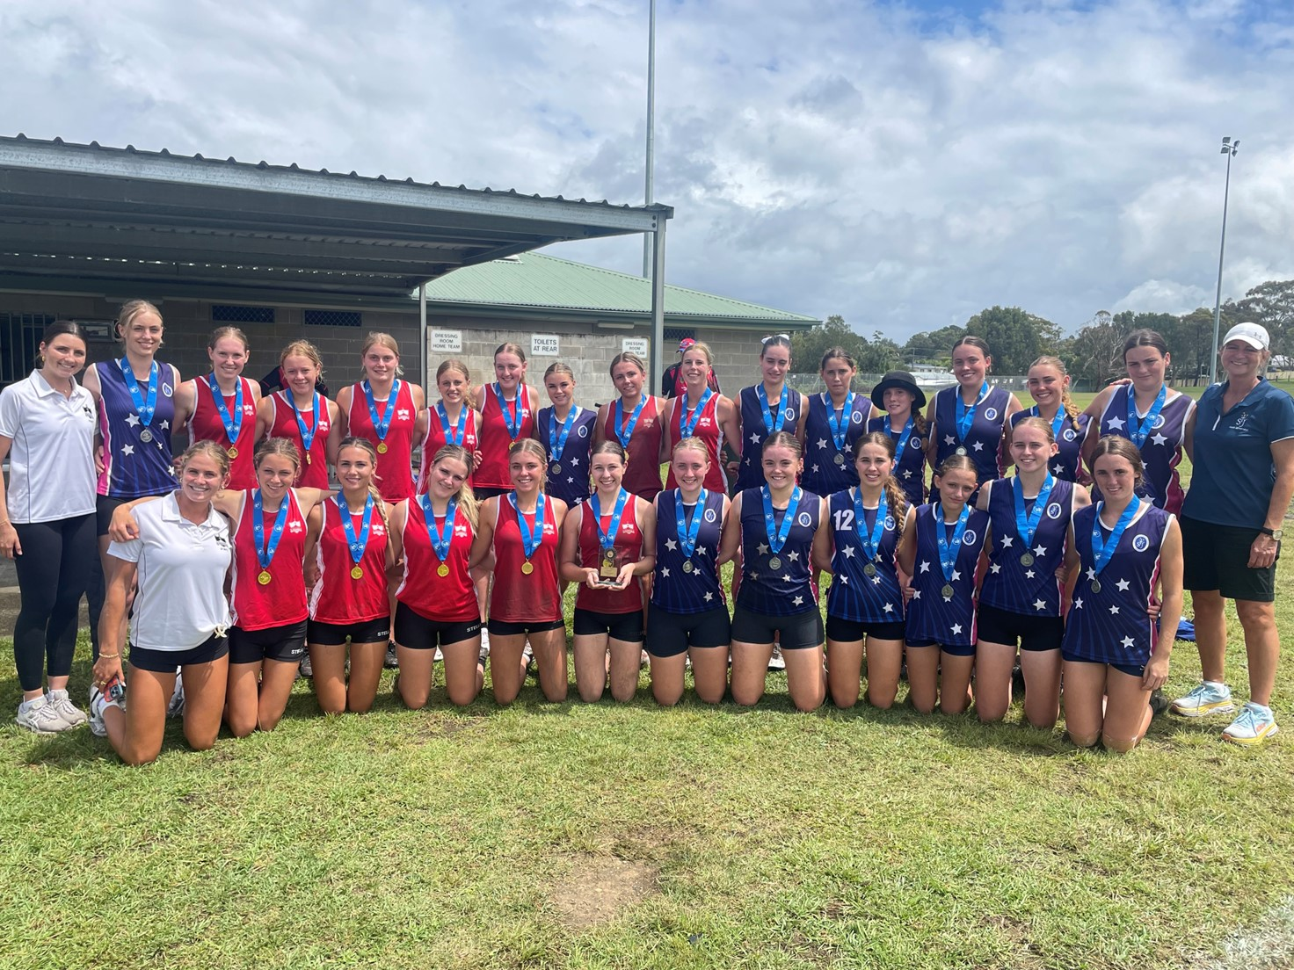

Open Boys
Champions - St Augustine's Brookvale
Runner's Up - Mater Maria Catholic College, Warriewood

Open Girls
Champions - Stella Maris, Manly
Runner's Up - St Joseph's Catholic College, East Gosford

U15 Boys
Champions - St Augustines, Brookvale
Runner's Up - Mater Maria Catholic College, Warriewood

U15 Girls
Champions - Stella Maris, Manly
Runner's Up - Mount St Benedict College, Pennant Hills

U13 Boys
Champions - St Augustine's College, Brookvale
Runner's Up - St Edward's College, Gosford

U13 Girls
Champions - Stella Maris, Manly
Runner's Up - St Peter's Catholic College, Tuggerah

