2023 TEAMS
U15 BOYS
Benjamin | B
Stan | C
Enda | C
Kobie | F
Taj | G
Archie | H
Connor | M
Kye | M
Kallum | M
Jayden | M
Keanu | M
Kye | N
Brendan | R
Taj | S
Billy | S
Blake | T
Samuel | T
Nate | V
NON TRAVELING SHADOWS
Max | B
Luca | D
Benjamin | GB
Nixon | L

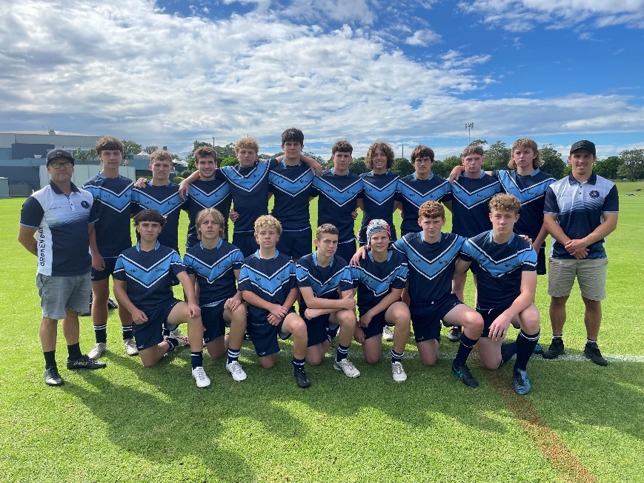
U18 BOYS
Team members highlighted in yellow have then gained selection into the U18 Combined Catholic Colleges Metropolitan Team.

Sean | B
Zane | S
Malachi | S
Devonte | V
David | K
Blake | L
Harry | B
James | B
Michael | F
Bryson | G
Benjamin | G
Finn | O
Harley | O
U18 GIRLS
Broken Bay students selected into the inaugural U18 Girls Metropolitan Team
Team members highlighted in yellow have then gained selection into the U18 Combined Catholic Colleges Team.
Isabella | F
Anabelle | R
Sienna Mae | M
Luciana | C
Dakota | P
Daisy | M
Sienna | D

U16 GIRLS
Team members highlighted in yellow have then gained selection into the U16 Combined Catholic Colleges Metropolitan Team.
Tyra | F | MacKillop Catholic College, Warnervale
Lacey | R | MacKillop Catholic College, Warnervale
Brianna | W | MacKillop Catholic College, Warnervale
Sienna | T | St Brigid's Catholic College, Lake Munmorah
Georgie | L | St Joseph's Catholic College, East Gosford
Lahni | M | St Joseph's Catholic College, East Gosford
Rachel | H | St Leo's Catholic College, Wahroonga
Bailey | L | St Leo's Catholic College, Wahroonga
Scarlet | M | St Leo's Catholic College, Wahroonga
Amaya | S | St Leo's Catholic College, Wahroonga
Brooklyn | L | St Peter's Catholic College, Tuggerah
Eloise | L | St Peter's Catholic College, Tuggerah
Ainsley | M | St Peter's Catholic College, Tuggerah
Shayla | W | St Peter's Catholic College, Tuggerah

Non-travelling shadows:
Lara | R | St Peter's Catholic College, Tuggerah
Emily | NS | St Peter's Catholic College, Tuggerah
Jade | E | St Peter's Catholic College, Tuggerah
Lily | F | St Joseph's Catholic College, East Gosford

U16 Broken Bay Girls at NSWCCC Rugby League Trials
Last week six of our U16 girls competed at the NSWCCC Rugby League Trials as part of the NSW Catholic Metropolitan side. The girls spent time on Wednesday training with their team had the opportunity to meet Kezie Apps and Bo Vette-Welsh from The West Tigers NRLW team and listen to their experiences and advice. They were then given a tour of the amazing facilities at the NSW Rugby League Centre of Excellence before being presented with their Metro uniforms in the NSW State of Origin change rooms. On Thursday they played admirably against Sydney, Northern Country and Southern Country, coming away with a draw, win and a loss. Congratulations to Sienna T from St Brigid’s at Lake Munmorah who was selected to represented NSWCCC at the Inaugural ASSRL 16 Girls’ Rugby League Tournament at Port Macquarie in September.
