2022 BROKEN BAY REPRESENTATIVE RUGBY LEAGUE TEAMS
U16 Girls Team
The following girls were selected to represent Broken Bay at the 2022 Sydney Metropolitan Catholic Colleges U16 Rugby League Trials.
Highlighted girls were then selected to represent Broken Bay in the Sydney Metropolitan Catholic Colleges Team at the 2022 NSWCCC U16 Girls Rugby League Trials -
Holly B - St Leo’s
Millie T - Mackillop
Dakota P - St Joseph’s
Lilieta P - Mater Maria
Audrey P - St Leo’s
Molly M - Mater Maria
Georgie L - St Joseph’s
Isabella F - Mater Maria
Charli P - St Joseph’s
Lily F - St Joseph’s
Emily NS - St Peter’s
Polly W - Mater Maria
Annabelle R - MacKillop
Sienna Mae M - St Peter’s
Chloe K - MacKillop
Taya W - St Peter’s
Sienna T - St Brigid’s***
Sienna T then proceeded to gain selection into the inaugural NSWCCC team!
U15 Boys Team
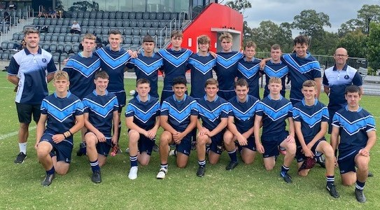
The following boys were selected to represent Broken Bay at the 2022 Sydney Metropolitan Catholic Colleges U15 Rugby League Trials.
Highlighted boys were then selected to represent Broken Bay in either the Sydney Metropolitan Catholic Colleges or Presidents Teams at the 2022 NSWCCC U15 Rugby League Trials -
Archie | B | MacKillop Catholic College, Warnervale
Kieran | D | St Edward's College, Gosford
Blake | F | MacKillop Catholic College, Warnervale
Samuel | F | St Edward's College, Gosford
Cooper | J | St Edward's College, Gosford
Tali | K | St Brigid's Catholic College, Lake Munmorah
Oscar | M | St Edward's College, Gosford
Brock | M | St Peter's Catholic College, Tuggerah
Blade | M | St Edward's College, Gosford
Jaykob | M | St Leo's Catholic College, Wahroonga
Archie | M | St Edward's College, Gosford
Luke | S | St Edward's College, Gosford
Tasman | S | MacKillop Catholic College, Warnervale
Darcy | S | St Edward's College, Gosford
Max | T | St Edward's College, Gosford
Nate | V | MacKillop Catholic College, Warnervale
Kieran | W | St Edward's College, Gosford
Tayte | B* | MacKillop Catholic College, Warnervale
* Subject to fitness
Non-Traveling Shadows
Joshua | B | St Edward's College, Gosford
Jay | C | St Edward's College, Gosford
Riley | H | MacKillop Catholic College, Warnervale
Izayah | T | St Paul's Catholic College, Manly

Jai | M | St Peter's Catholic College, Tuggerah

U18s
The following boys were selected to represent Broken Bay at the 2022 Sydney Metropolitan Catholic College U18 Rugby League Trials.
Highlighted boys were then selected to represent Broken Bay in either the Sydney Metropolitan Catholic Colleges or Presidents Team at the 2022 NSWCCC U15 Rugby League Trials -
Thomas | P | St Edward's College, Gosford
Joel | S | St Edward's College, Gosford
William | H | St Edward's College, Gosford
Tyrone | D | St Edward's College, Gosford
Benjamin | G | St Paul's Catholic College, Manly
Malachi | S | St Edward's College, Gosford
Emmet | N | St Edward's College, Gosford
Lauchlan | B | MacKillop Catholic College, Warnervale
Charles | C | St Edward's College, Gosford
David | K | Mater Maria Catholic College, Warriewood
Jack | L | St Edward's College, Gosford

