BROKEN BAY RUGBY SEVENS CHAMPIONSHIPS
Congratulations to our 2024 champions -
U14 Boys
Champions - St Brigid's Catholic College, Lake Munmorah
Runners Up - St Edward's College, Gosford
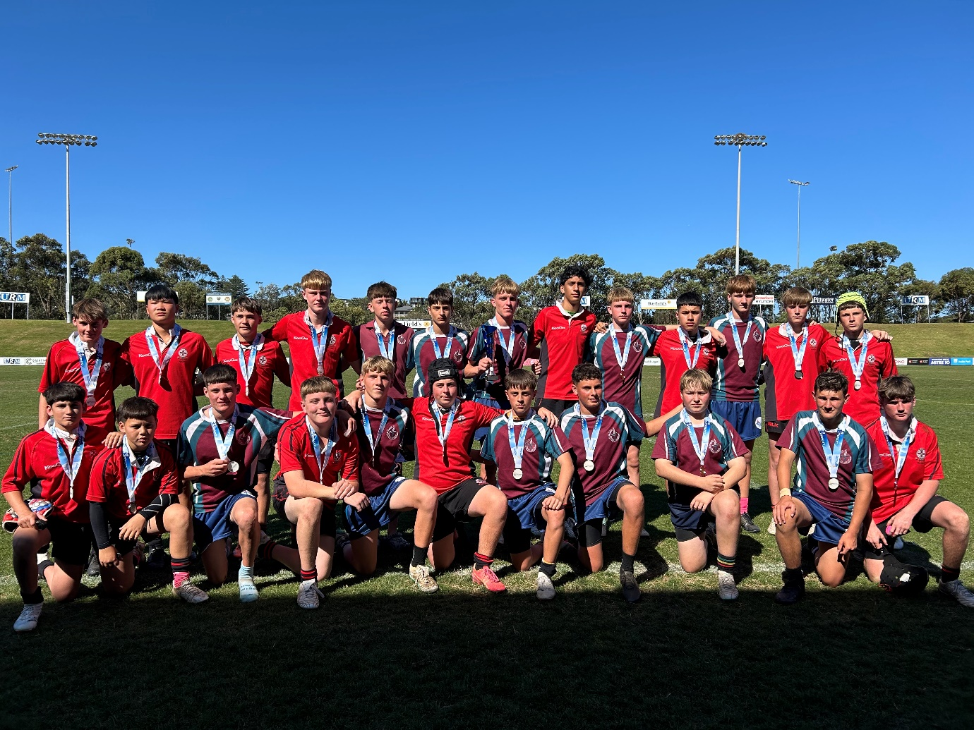
U16 Boys
Champions - Mater Maria Catholic College, Warriewood
Runners Up - St Edward's College, Gosford
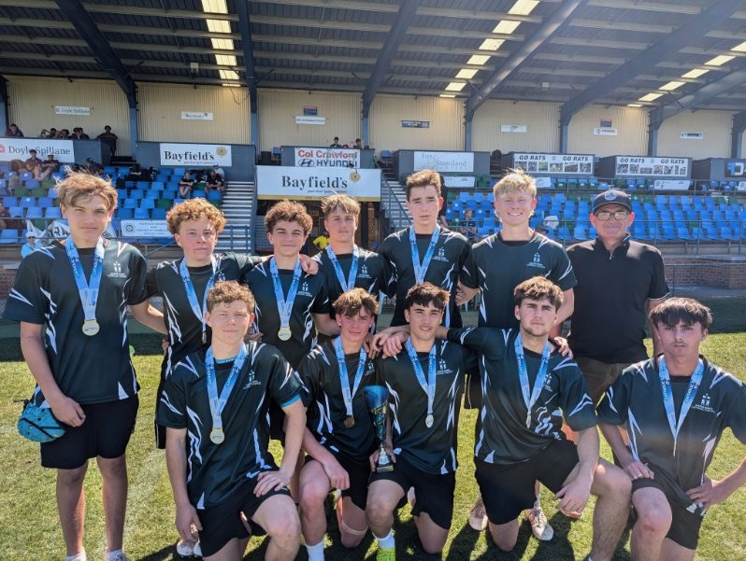

2023 BROKEN BAY RUGBY SEVENS CHAMPIONSHIPS RESULTS
U14 Boys Champions: Mater Maria
U14 Boys Runners Up: St Edward’s
U14 Girls Champions: Stella Maris
U14 Girls Runners Up: St Peter’s
U16 Boys Champions: St Edward’s
U16 Boys Runners Up: St Paul’s
U16 Girls Champions: Mount St Benedict’s
U16 Girls Runners Up: Mater Maria

2022 BROKEN BAY RUGBY SEVENS CHAMPIONSHIPS RESULTS
U14 Boys Champions: Mater Maria
U14 Boys Runners Up: St Edward’s
U16 Boys Champions: St Edward’s
U16 Boys Runners Up: St Brigid’s

