2024 Broken Bay Cross Country representatives
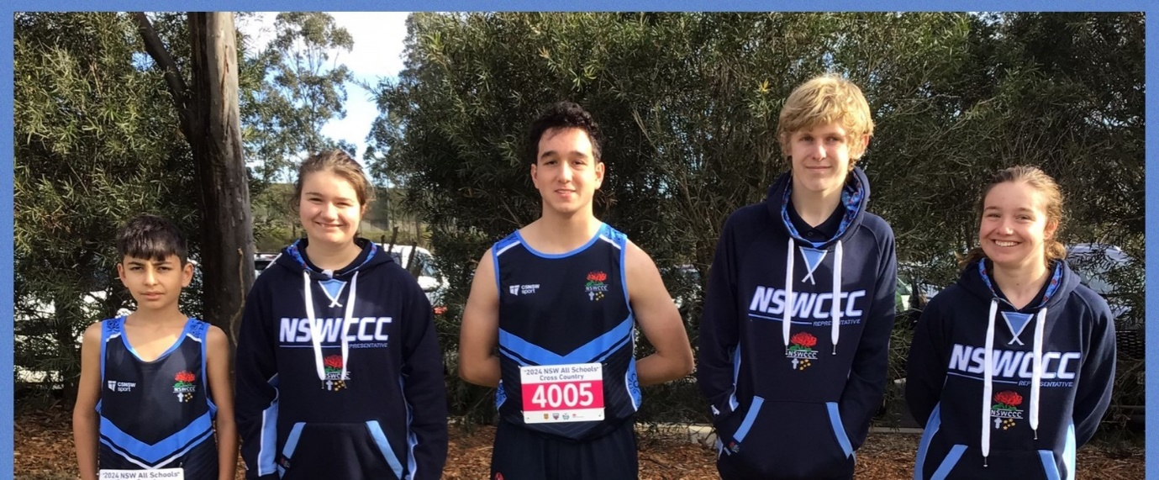
Pictured above - St Edmunds College, Wahroonga, who had 5 students compete at the 2024 NSW All Schools Cross Country including Daniel Nunes who finished 3rd in the 12-14 yrs Multi-class event
BROKEN BAY REPRESENTATIVE TEAM
Congratulations to the following athletes who gained selection into the 2024 Broken Bay Cross Country Team -
The students highlighted in yellow have gained selection into the NSWCCC Cross Country Team
A | Dylan | St Edmund's College, Wahroonga
A | McInnes | Brigidine College, St Ives
A | Harper | Brigidine College, St Ives
A | Caylon | St Peters
A | Asher | St Edward's
B | Logan | St Edwards's
B | James | St Edward's
B | Fraser | St Edward's
B | Piper | Stella Maris College
B | Maximus | St Paul's Manly
B | Chase | St Brigid's Catholic College
B | Tristan | St Peters Tuggerah
C | Ivan | St Leo's Catholic College
C | Jack | MacKillop
C | Emilie | Mount St Benedict College
C | Fowler | Brigidine College, St Ives
C | Cornes | Brigidine College, St Ives
C | Conor | St Leo's Catholic College
C | Emily | Stella Maris College
CS | Kobi | St Paul's Manly
D | Dustin | St Paul's Manly
D | Cameron | St Edmund's College, Wahroonga
D | Milla | St Peters
D | Lachlan | St Edward's
EB | Isabelle | Mercy Catholic College
E | Gemma | Brigidine College, St Ives
E | Shanahan | Brigidine College, St Ives
F | Callum | Mater Maria Catholic College
F | Lucy | St Edmund's College, Wahroonga
F | Ben | St Edmund's College, Wahroonga
F | Eva | Mount St Benedict College
G | Makenzi | Mercy Catholic College
G | Cooper | Mater Maria Catholic College
G | Ava | Mater Maria Catholic College
G | Seth | MacKillop
H | Kaylen | St Leo's Catholic College
H | Bonnie | Mount St Benedict College
H | Imogen | Mount St Benedict College
H | Eleanor | Mount St Benedict College
H | Connor | MacKillop
H | Bradley | St Edmund's College, Wahroonga
HG | Jaydon | St Edmund's College, Wahroonga
J | Isaac | St Edmund's College, Wahroonga
J | Hayden | St Peters
K | Oliver | St Brigid's Catholic College
K | Amber | Stella Maris College
L | Sophia | St Edmund's College, Wahroonga
L | Isabella | St Edmund's College, Wahroonga
L | Isaac | St Peters
L | Charlie | Mercy Catholic College
L | Aidan | St Peters
L | Saxon | Mater Maria College
L | Alice | Mount St Benedict College
M | Jack | St Brigid's Catholic College
M | Max | Mater Maria Catholic College
M | Amelia | Stella Maris College
M | Max | St Leo's Catholic College
M | Billy | St Edward's
M | Daniel | St Edward's
M | Jodie | St Joseph's Catholic College, East Gosford
M | Links | Brigidine College, St Ives
N | Andrea | Stella Maris College
N | Daniel | St Edmund's College, Wahroonga
P | Eden | St Edward's
P | Eli | St Edward's
P | Colin | St Leo's Catholic College
P | Keith | St Leo's Catholic College
P | Daniella | Mercy Catholic College
P | Sophie | Mount St Benedict College
Q | Philippa | Stella Maris College
R | Jensen | St Peters
R | Lyla | Stella Maris College
R | Jariah | St Brigid's Catholic College
R | Isaiah | St Brigid's Catholic College
SN | Marcelo | St Leo's Catholic College
S | Bronte | St Joseph's Catholic College, East Gosford
S | Sienna | St Joseph's Catholic College, East Gosford
S | Zali | Mount St Benedict College
S | Ella | St Leo's Catholic College
S | Brodie | MacKillop
S | Chelsea | St Leo's Catholic College
S | Willow | St Joseph's Catholic College, East Gosford
S | Liam | St Peters
SF | Jack | St Paul's Manly
S | Alice | Mount St Benedict College
T | Gemma | Mercy Catholic College
T | David | St Edmund's College, Wahroonga
T | Archie | St Leo's Catholic College
T | Freya | St Leo's Catholic College
T | Riley | St Edwards's
U | April | Stella Maris College
VH | Lucy | Mount St Benedict College
Z | Zane | St Edmund's College, Wahroonga

