2024 Broken Bay Cross Country representatives
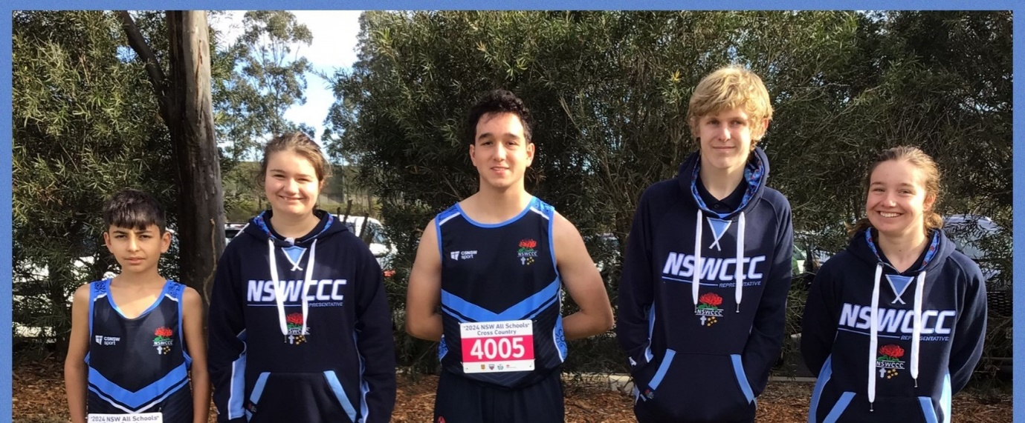
Pictured above - St Edmunds College, Wahroonga, who had 5 students compete at the 2024 NSW All Schools Cross Country including Daniel Nunes who finished 3rd in the 12-14 yrs Multi-class event
BROKEN BAY REPRESENTATIVE TEAM
Congratulations to the following athletes who gained selection into the 2024 Broken Bay Cross Country Team -
The students highlighted in yellow have gained selection into the NSWCCC Cross Country Team
Ainscow | Dylan | St Edmund's College, Wahroonga
Albee | McInnes | Brigidine College, St Ives
Alexopulos | Harper | Brigidine College, St Ives
Allen | Caylon | St Peters
Armstrong | Asher | St Edward's
Barlow | Logan | St Edwards's
Blow | James | St Edward's
Boake | Fraser | St Edward's
Brenchley | Piper | Stella Maris College
Bryant | Maximus | St Paul's Manly
Bullock | Chase | St Brigid's Catholic College
Burn | Tristan | St Peters Tuggerah
Caceres | Ivan | St Leo's Catholic College
Casey | Jack | MacKillop
Chandran | Emilie | Mount St Benedict College
Charlotte | Fowler | Brigidine College, St Ives
Claire | Cornes | Brigidine College, St Ives
Collins | Conor | St Leo's Catholic College
Cunningham | Emily | Stella Maris College
Currie-Stuart | Kobi | St Paul's Manly
Dampney | Dustin | St Paul's Manly
Davidson | Cameron | St Edmund's College, Wahroonga
Davies | Milla | St Peters
Donafee | Lachlan | St Edward's
El-Badini | Isabelle | Mercy Catholic College
Elliot | Gemma | Brigidine College, St Ives
Erin | Shanahan | Brigidine College, St Ives
Fitzsimmons | Callum | Mater Maria Catholic College
Fox | Lucy | St Edmund's College, Wahroonga
Fraser | Ben | St Edmund's College, Wahroonga
Frith | Eva | Mount St Benedict College
Gartner | Makenzi | Mercy Catholic College
GRAY | Cooper | Mater Maria Catholic College
GRAY | Ava | Mater Maria Catholic College
Guerin | Seth | MacKillop
Hackett | Kaylen | St Leo's Catholic College
Harkin | Bonnie | Mount St Benedict College
Hays | Imogen | Mount St Benedict College
Heard | Eleanor | Mount St Benedict College
Hibbard | Connor | MacKillop
Hitchcock | Bradley | St Edmund's College, Wahroonga
Hyde-Grofski | Jaydon | St Edmund's College, Wahroonga
Jackson | Isaac | St Edmund's College, Wahroonga
Jones | Hayden | St Peters
Knapman | Oliver | St Brigid's Catholic College
Koi | Amber | Stella Maris College
Law | Sophia | St Edmund's College, Wahroonga
Law | Isabella | St Edmund's College, Wahroonga
Lear | Isaac | St Peters
Lill | Charlie | Mercy Catholic College
List | Aidan | St Peters
Lund | Saxon | Mater Maria College
Lyng | Alice | Mount St Benedict College
MacMohan | Jack | St Brigid's Catholic College
Mancell | Max | Mater Maria Catholic College
Mandalic | Amelia | Stella Maris College
Mayhew | Max | St Leo's Catholic College
McCarthy | Billy | St Edward's
McCarthy | Daniel | St Edward's
Mead | Jodie | St Joseph's Catholic College, East Gosford
Mia | Links | Brigidine College, St Ives
Nel | Andrea | Stella Maris College
Nunes | Daniel | St Edmund's College, Wahroonga
Pearson | Eden | St Edward's
Pepper | Eli | St Edward's
Perez | Colin | St Leo's Catholic College
Perez | Keith | St Leo's Catholic College
Perez | Daniella | Mercy Catholic College
Polkinghorne | Sophie | Mount St Benedict College
Quarrell | Philippa | Stella Maris College
Ratcliff | Jensen | St Peters
Rigby | Lyla | Stella Maris College
Rosit | Jariah | St Brigid's Catholic College
Ryan | Isaiah | St Brigid's Catholic College
Sanchez-Nicholls | Marcelo | St Leo's Catholic College
Scahill | Bronte | St Joseph's Catholic College, East Gosford
Scahill | Sienna | St Joseph's Catholic College, East Gosford
Scheenen | Zali | Mount St Benedict College
Searles | Ella | St Leo's Catholic College
Slattery | Brodie | MacKillop
Smeallie | Chelsea | St Leo's Catholic College
Smith | Willow | St Joseph's Catholic College, East Gosford
Smith | Liam | St Peters
Snyder-Firth | Jack | St Paul's Manly
Soalheiro | Alice | Mount St Benedict College
Tait | Gemma | Mercy Catholic College
Teichtahl | David | St Edmund's College, Wahroonga
Tod | Archie | St Leo's Catholic College
Tonkin | Freya | St Leo's Catholic College
Turner | Riley | St Edwards's
Unwin | April | Stella Maris College
van Hooft | Lucy | Mount St Benedict College
Zofrea | Zane | St Edmund's College, Wahroonga

