2025 Broken Bay Basketball Championships
Congratulations to our 2025 champions -

Open Boys:
Champions: St Edward's College, Gosford
Runner's Up: St Paul's Catholic College, Manly
Open Girls:
Champions: Mater Maria Catholic College, Warriewood
Runner's Up: St Brigid's Catholic College, Lake Munmorah
Int Girls:
Champions: St Joseph's Catholic College, East Gosford
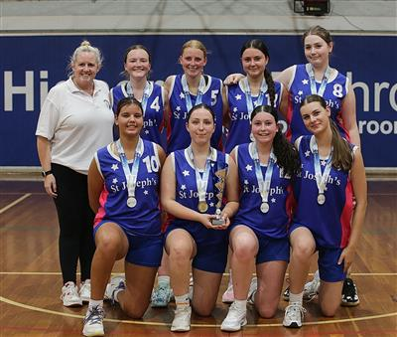
Runner's Up: Mater Maria Catholic College, Warriewood
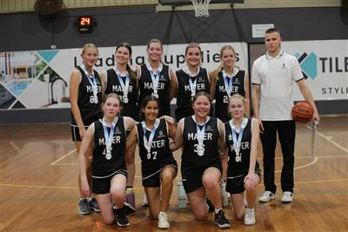
Int Boys:
Champions: St Paul's Catholic College, manly
Runner's Up: Mater maria catholic College, Warriewood
Jnr Girls:
Champions: Mercy Catholic College, Chatswood
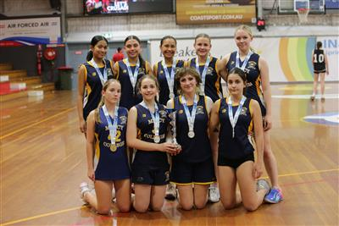
Runner's Up: St Joseph's Catholic College, East Gosford
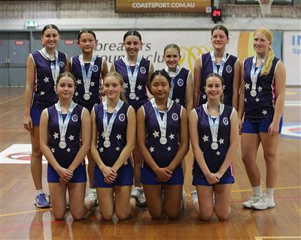
Jnr Boys:
Champions: St Peter's Catholic College, Tuggerah
Runner's Up: St Edward's College, Gosford

