All School-based competition registrations must be done by an endorsed School Sports Coordinator OR Principal Delegate.

STAFF APPLYING FOR SPORTS COORDINATOR

- On the staff dashboard, go to STAFF and select APPLY FOR SPORT COORDINATOR
- Select your school
- Click on the link to Sport Coordinator Terms and Conditions to read
- Tick the box to acknowledge that you have read and agree to the Terms and Conditions
- Click on SUBMIT
- Once approved online by your Principal, you will receive an email notification notifying you of approval.

PRINCIPAL APPROVING YOUR REQUEST

Your Principal will need to do the following:

Login to their account and go to Staff Dashboard
- A red notification will be on the Staff Applications box (See below).
- Click on this OR go to ADMIN and select Approval for Sports Position
- Select the “Role” and click on the required action (Approve/Declined)
- Click on APPROVE

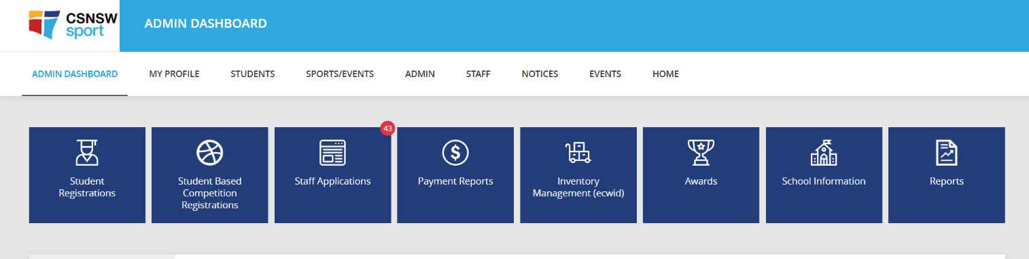
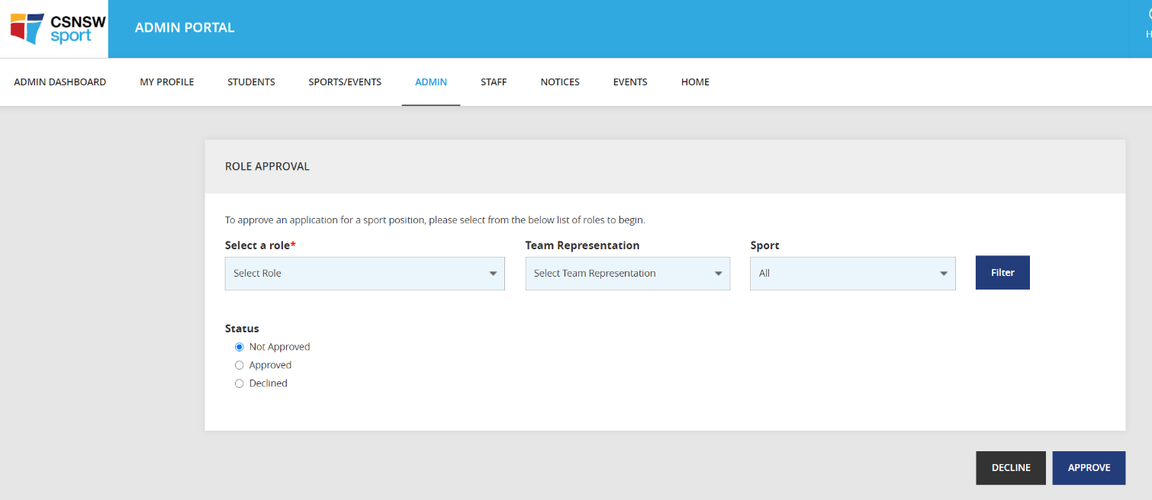
OR

PRINCIPAL GIVING AUTHORITY TO A STAFF MEMBER TO APPROVE STUDENT REGISTRATIONS - Principal Delegation

- The principal logs into their CSNSW Sport account and then goes to the dashboard.
- In the ADMIN drop-down menu, select PRINCIPAL DELEGATION
- Type in the school’s name.
- A list of registered staff will appear in the drop-down box under SELECT STAFF
- Click on the staff member to whom you wish to delegate your approval authority.
- Click DELEGATE
- The selected staff member will now be able to approve student registrations and apply for School-base competitions on the Principal’s behalf.

REGISTERING YOUR SCHOOL-BASED TEAM
The school Sports Coordinator is expected to register their school team via the portal. Please see below how to register.

- To enter your school, please go to your dashboard on the portal (login)
- Please go to the 'STAFF' tab and click 'SCHOOL COMPETITION SEARCH'.
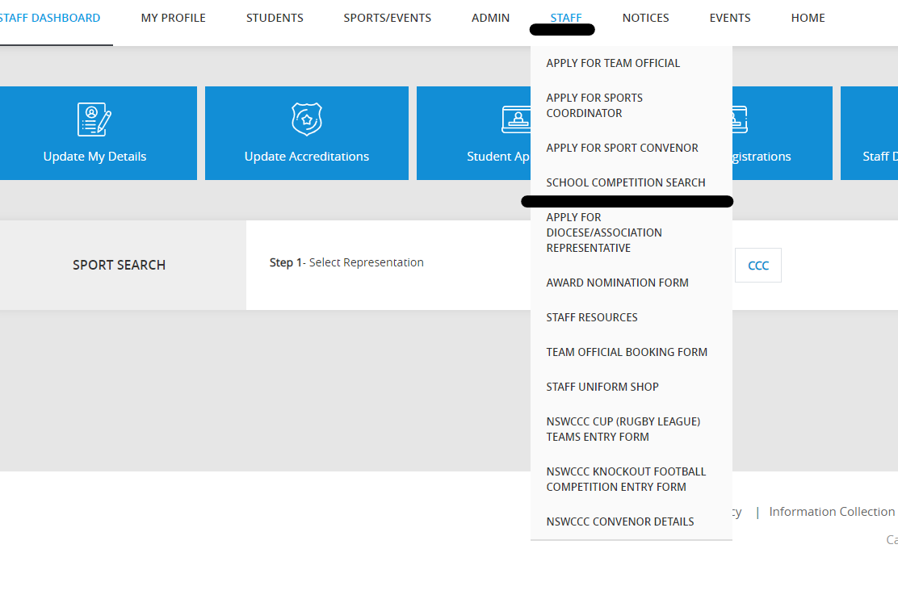

- Click the blue 'SCHOOL COMPETITION ENTRIES' box in the right-hand corner.
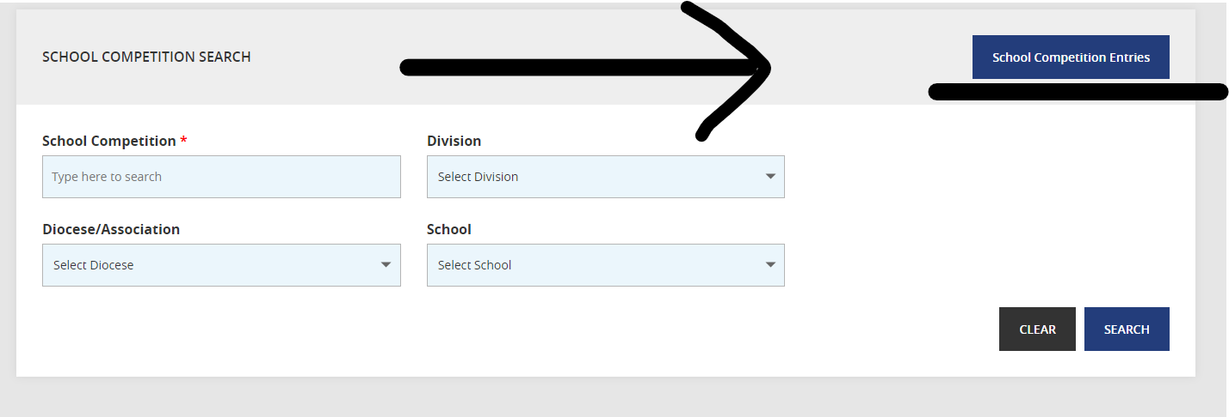
- Fill out the relevant information in the fields below – all fields are required, then click ‘add team’. Some more questions will appear below, please complete then you will be able to proceed.
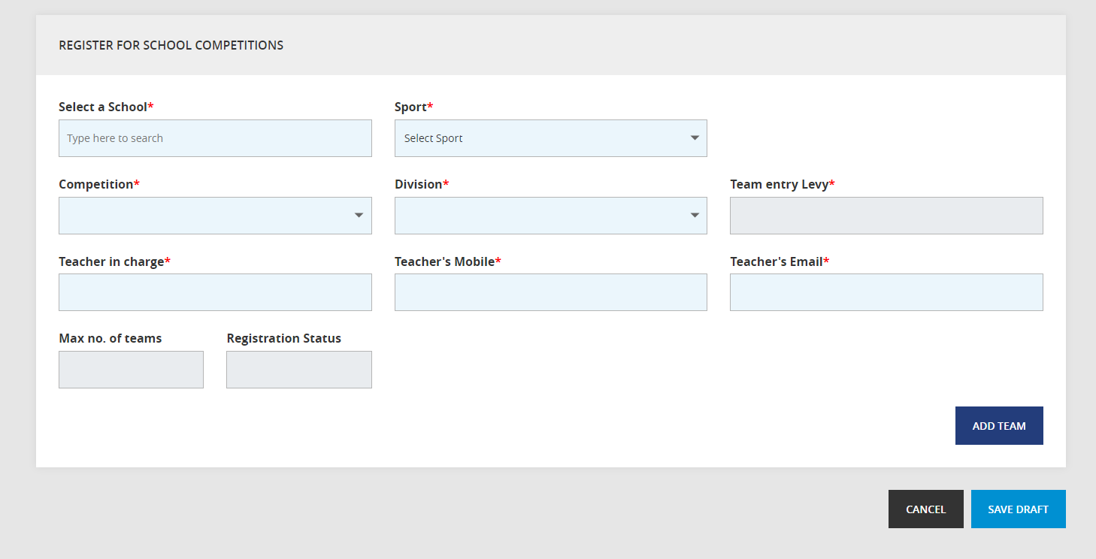
- Entries are not confirmed until payment has been received. Payment can be via credit card or direct debit (invoice). Please click ‘send me a copy’ with finishing and take this to your finance team at your school.
- Please refresh your page after entering each division.

