# **SCHOOL COMPETITIONS**

This applies to Principals and Sports Coordinators registering schools for School Competitions.

Please follow the instructions below.

1. To enter your school, please go to your dashboard on the portal (login)
2. Please go to the 'STAFF' tab, click 'SCHOOL COMPETITION SEARCH'.

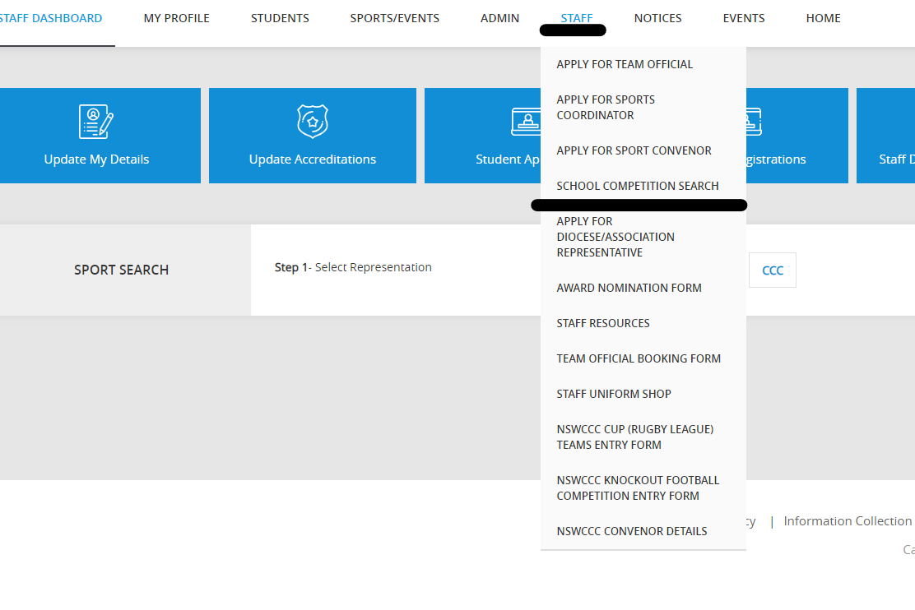

1. Click the blue 'SCHOOL COMPETITION ENTRIES' box in the right-hand corner.

# **SCHOOL COMPETITIONS**

1. Fill out the relevant information in the fields below – all fields are required.

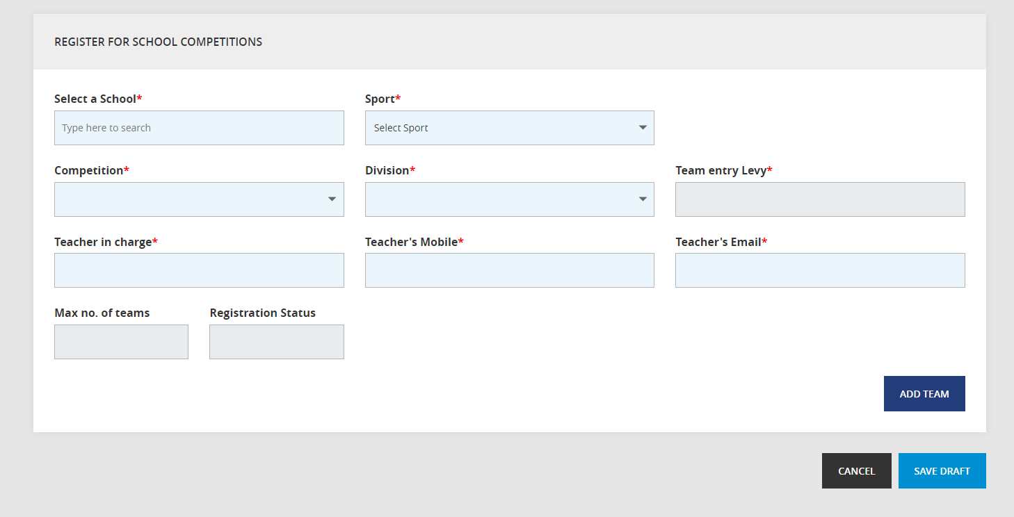

1. Entries are not confirmed until payment has been received. Payment can be via credit card or direct debit (invoice).
2. Please refresh your page after entering each division.