

EVENT RISK ASSESSMENT & MANAGEMENT PLAN
EVENT CRITICAL INCIDENTS MANAGEMENT PLAN

2023
AFL Polding
Tues, 4 April
Bateau Bay AFL Oval

HOW TO USE THIS DOCUMENT
Any content in italicised grey print is for the user to update and adjust to be relevant to the event the plan is for. The greyed out text may be removed if not relevant. Any text in BLACK and not italicised or a blue hyperlink must be kept in the document.

DETAILS
Date | Tues 4 April 2023
Event | Polding AFL Selection
Location of Booking | Bateau Bay AFL Oval
Areas of Operation | Bateau Bay AFL Oval
Contact Name | Julia-Ann Thompson
Position | Broken Bay Diocese Representative
Contact Number | 0417 436 185

CONTACT POINTS

Event Convenor | Julia-Ann Thompson | 0417 436 185
Venue Administration | Central Coast Council | 02 4306 7900

Emergency Services |  | 000
Hospital | Gosfprd Hospital  75 Holden St, Gosford NSW 2250 | 0243202111
Medical Centre | Bateau Bay Medical Centre, 599 The Entrance Rd, Bateau Bay NSW 2261 | 0243326411
Police | 12 Dening St, The Entrance NSW 2261 | 0243332999

Nearest crossroads | Passage Rd and Cotton St
Location of Emergency Services Access | Passage Rd and Cotton St

EVENT RISK MANAGEMENT PLAN
EVENT | Polding AFL | DATE | 4 April 2023
LOCATION | Bateau Bay AFL Oval | STAFF  CONTACTS
# PARTICIPANTS | 50 | # SPECTATORS | 50

Assess Risk Appetites using guide >> CSNSW SPORT RISK APPETITE ASSESSMENT TOOL
1 | Risk Description |  |  | Impact | Likelihood | Rating
There is a risk that event is not managed effectively, resulting in injury or decreased wellbeing to students, spectators and staff and reputational risk to CSNSW. |  |  | Residual Risk:  (Actual Key Controls in Place) | Moderate (5) | Possible (3) | Moderate (15)
Risk Category |  |  | Target Baseline Risk:  (All Key Controls in Place) | Minor (3) | Unlikely (2) | Low (6)
Risk Owner |  | CSNSW Sport | Inherent Risk:  (No Key Controls in Place) | Major (7) | Possible (3) | High (21)
Possible Impacts |  | - Operational effectiveness: Operational ineffectiveness stemming from inefficiencies in organising event, resulting in an inability for students to begin a pathway to elite sport.  - Financial: Decrease in revenue going forward, costs associated with damages caused by CSNSW through act or omissions.  - People: Mental, physical, social wellbeing of participants decreased (injury risk), increased absenteeism and decrease of staff morale, parent dissatisfaction.  - Reputation: Significant reputational damage in terms of the ability of the Catholic School System to provide effective sport offering. Sporting students unmotivated to achieve their sporting goals through Catholic pathways. No value add proposition to broader Catholic system.  - Regulatory/Legislative: Penalties for failure to meet legislative duty of care or other legislative compliance.
Cause(s) |  |  | Strategies/Controls
- Behaviours & Conduct |  |  | - All participants’ parent/guardian have acknowledged and agreed to a Student Code of Conduct when registering. Student Code of Conduct >>>  - Event Code of Behaviour for spectators, officials and team management to be included in event program. Event Code of Conduct >>>  - Code of Conduct and behaviour reiterated at pre event meeting and in programs
- Lack of traffic management |  |  | - Traffic management plan>>> included in venue map in this document
- Injury and medical emergencies |  |  | - A designated first aid officers will be in attendance and visible, equipped with a medical kit and ice.  - Qualified teachers are in attendance  - Injury register>> Plus injuries & incidents must be recorded on http://csnsw.csassurance.com/contracts/new?contract_template=29&token=s5jKhxYyvU6qZfh4KEvJ  - Equipment utilized is inspected prior to use by staff and maintained to safe industry/Aust. Standards where specified.  - Venues have ambulance access>>>  - Emergency details>>>  - Parents are to record medical history and medications on child’s registration.  - Teachers, carers, are responsible for identifying participants with pre-existing injuries, ailments or conditions which may affect participation, safety and wellbeing.  - Attending teachers, carers, other adults are to be in possession of treatment plans and medication for known allergies and reactions (e.g. Asthma puffer; Epi-Pens; Adrenalin; etc…)  - Proper Attire to be worn appropriate for participation in the sport - Bare feet are not acceptable  - Taps and water cooler access is provided.  - All participants are reminded to bring their own drink and protective equipment if required  - CSNSW Sport staff will engage staff trained in FA treatment. Basic medical equipment onsite. Access to emergency medical support  - Student progress from school to Diocesan level must have a level of skill required to compete CSNSW Sport – Polding event.
- Inadequate resources |  |  | - Engage the use of qualified officials.  - CSNSW to ensure staff presence at event.  - Equipment – Students to provide own playing equipment.  - Venue “On the Day Risk Management” completed  - Designated first aid officer provided.  - Injury register. All serious injuries & incidents must be recorded on http://csnsw.csassurance.com/contracts/new?contract_template=29&token=s5jKhxYyvU6qZfh4KEvJ  - Kiosk facilities or access to club facilities operating.  - Shaded areas for spectators and competitors
- Inadequate information, training and support |  |  | - Update emails distributed to Dioceses and registered participants regularly  - Rules and general information available on CSNSW SPORT website.  - Induction meeting for all Diocesan Team Officials.  - Emails to competitors with links competition rules, reminders about hydration and being sun smart (if relevant).  - Bottled Water & lunch provided for event and team officials  - Event Officials identifiable.  - All staff have access to DoE Sports Specific Guidelines, CSNSW Sport Operational Guidelines
- Venue and competition hazards – debris, natural environment (eg weather, pot holes etc), misdirected equipment (balls, corner posts), tackles & scrums |  |  | - Area of play checked before start of event – “On the Day Risk Management” Checklist” >>> completed  - Equipment maintained by local authority or management.  - Playing area maintained by local authority or management.  - Time & space allowed for warm up  - Recommend students carry fluids – Provide water station  - Recommend students apply sunscreen and wear a hat for outdoor events.  - Competition area defined to restrict spectator intrusion.  - Covered area at key assembly points for outdoor venues  - Wheelchair access available  - COVID-19 Safety Plan applied –, hand sanitiser available
- Inappropriate equipment |  |  | - Convener/ CSNSW Sport to provide team playing equipment. Students to provide own personal protection, and playing equipment  Any sizes, weights of equipment as per sport specific guidelines.
- Child protection related issues |  |  | - Educational Institution staff and staff engaged by CSNSW SPORT comply with NSW Working with Children Legislation and have participated in employment screening.  - Specific control areas restrict public access ie: delineated competitor area. Event staff will enforce control points.  All match officials engaged by CSNSW Sport will complete the online Child Protection Module and be added to the CSNSW Sport WWC register.
- Emergency situations not planned for |  |  | - Each venue displays emergency procedure template  - Managers to identify muster points at meeting in morning prior to start of event.  - Include muster points map>>> in program  - Review Adverse Weather >>> procedures.  - CSNSW Sport Emergency Procedures >>>
- COVID 19 Restrictions and safety |  |  | - The CSNSW Sport COVID 19 Safety Plan will be the overarching framework for COVID 19 Management >> CSNSW SPORT COVID-19 SAFETY PLAN  - Each venue will have a COVID Safety pack which will include- COVID Marshal vests, gloves, face masks, hand sanitiser, disinfectant wipes, a QR Code, a paper record keeper, Safety Signs.  - CSNSW Sport COVID Safety Plan will operate in conjunction with venue plan. The more conservative plan will be adopted.  - All current health orders including venue numbers will be adhered to  - Bateau Bay has been booked for the trials to occur.  - Team managers will be responsible for taking a role of all players in their team.

TRAFFIC MANAGEMENT & EMERGENCY EVACUATION

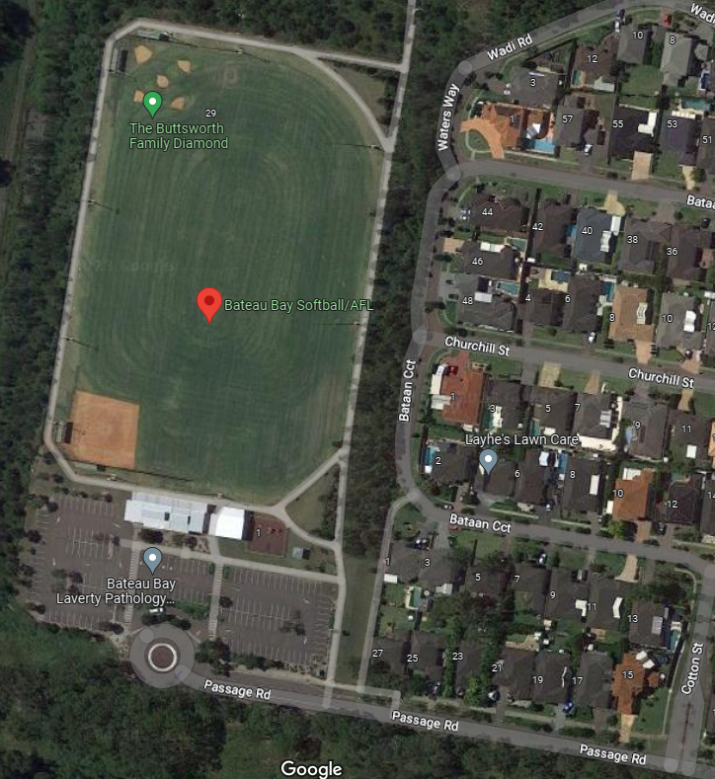

PLAN KEY:
 | Entry Point |  | Emergency Muster Point |  | First Aid station
 | Emergency Access |  | Player/official exclusive zone

CATHOLIC SCHOOLS NSW SPORT

On the Day of the Event Checklist
This document needs to be completed by the Event Manager or the nominated person when managing the listed event under the auspices of CSNSW SPORT. This must be completed on the day, prior to the commencement of the event. It may need to be revisited throughout the day as conditions change.
In your venue assessment if the “No” column is ticked, please confirm remediation in “Comment” column.

EVENT | SPORT | AFL Polding | SELECTION | X
EVENT | VENUE | Bateau Bay AFL Oval | KNOCKOUT
EVENT | DATE | 4 April 2023 | CHAMPIONSHIP
EVENT | TIME |  | CARNIVAL
 |  |  |  |  |  | YES |  | NO |  | N/A |  | COMMENT
TRANSPORT | Ensure the traffic management plan is in place.
STAFFING | Have all team officials signed the registration sheet and confirmed their understanding of relevant policies and procedure? (Name, Mobile, School, participant numbers)
STAFFING | Have all event officials signed the registration sheet and confirmed their understanding of relevant policies and procedure?
STAFFING | Do all event officials have name tags and identifiable clothing?
STAFFING | Do all event officials have working mobile phones?
STAFFING | Ensure all staff have access to the Carnival Manager’s mobile number
STAFFING | Have we distributed documentation for key aspects of relevant policies and procedures?
STAFFING | Does the Carnival Manager have internet access?
STAFFING | Does each key person know their specific role/s?
STAFFING | Have all staff been briefed on the key aspects of the events? Eg duty of care of all individuals
VENUE INFORMATION | Toilets are accessible, clean and workable including disabled facilities
VENUE INFORMATION | Drinking water is available and accessible
VENUE INFORMATION | Confirm emergency vehicle have access
VENUE INFORMATION | Confirm canteen is open and operable
VENUE INFORMATION | Sunscreen is available at control area
EQUIPMENT | Is all equipment appropriately secured to prevent injury?
EQUIPMENT | Check equipment meets sport safety specifications
EQUIPMENT | All individuals & teams are aware of regulations regarding safety equipment
COMPETITION AREA | Has the competition area been checked for irregularities?
COMPETITION AREA | Is the competition area safe to proceed with the event? Eg Water quality, surface stability
SPECTATOR AREA | Clearly defined and separate from competition area
SPECTATOR AREA | Has the spectator area been checked for irregularities?
SPECTATOR AREA | Are bins accessible for rubbish disposal?
FIRST AID ARRANGEMENTS | Has the appointed first aid officer arrived at the logged time? |  |  |  |  |  |  |  |  |  | TIME:
FIRST AID ARRANGEMENTS | Has the first aid officer been briefed on emergency procedures?
FIRST AID ARRANGEMENTS | Identify student with medical alerts and provide action plans if necessary
FIRST AID ARRANGEMENTS | Is the first aid room open and clean and clearly identified?
FIRST AID ARRANGEMENTS | Do the first aid arrangements meet the requirements of the activity/event. I.e. nature of the event, number of attendees
FIRST AID ARRANGEMENTS | Is ice available?
ENVIRONMENTAL CONDITIONS | Is there the potential for the competition to be interrupted by an environmental factor? If so, What?
ENVIRONMENTAL CONDITIONS | Do you have a plan to counter extreme environmental factors?
APPROXIMATE ATTENDANCE NUMBERS | Number of Staff
APPROXIMATE ATTENDANCE NUMBERS | Number of Students
APPROXIMATE ATTENDANCE NUMBERS | Number of Spectators

In signing this you acknowledge that you have read and understand the Control Sheet and the Risk Register in relative to this event. At the conclusion of the event, please sign and promptly return to the CSNSW SPORT office.
VENUE MANAGER | NAME |  | DIO REP/ CSNSW SPORT | NAME
VENUE MANAGER | DATE |  | DIO REP/ CSNSW SPORT | DATE
VENUE MANAGER | MOBILE |  | DIO REP/ CSNSW SPORT | MOBILE
VENUE MANAGER | SIGNATURE |  | DIO REP/ CSNSW SPORT | SIGNATURE

EVALUATION: At the conclusion of the event please provide feedback for future planning
WHAT HAS BEEN TO ADDRESS ANY CONCERNS ?

Paperwork is available:
- Codes of Conduct
- Sport Specific Guidelines/By Laws
- Medical/Accident Report Forms
- Evacuation Procedures
- Please make any comments that you feel are relevant regarding the safety at this venue.

Please email the completed copy to the CSNSW Sport Manager at the conclusion of the event
sport@CSNSW.catholic.edu.au

Attachment A

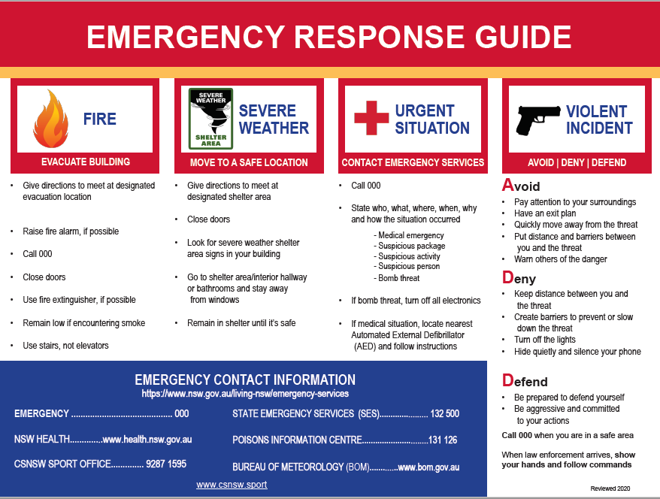

Attachment B -
Specific Risk Assessment for General Equipment / AFL

Category | Danger / Hazard | Risk Mitigation Strategy | Risk Rating
General Equipment  This includes general use shared equipment such as tents, lights and vehicles  Clothing, Shoes and Apparel | Equipment defective  Players not adequately dressed including football boots /rings/necklaces | Ground staff check equipment and areas before event  Students clothing, apparel and equipment checked by officials  CSNSW ensure adequately trained medical staff are engaged  Clothing, boots and uniform checked by officials.  Also check the studs of the boots where required  Check no rings and necklaces warn by participants. | Low
Condition of football field | Hazards on the football field and football field not of safe for players | Football field examined for foreign objects  Porous surfaces should be cleaned regularly to allow drainage.  Ensure adequate maintenance and regular inspection.  Ensure football field markings are clear including the use of cones or other such object as required  Ensure surrounds are clear of foreign objects | Low
Condition of AFL Equipment  Sun damage | Ensure the balls are pumped to the correct pressure  Ensure hooter is in working order  Sun Damage | Ensure by checking pregame by officials the balls are not too firm not too deflated as this can lead to injury  Testing hooter  Appropriate clothing, hats, sunscreen – sun safe wear is utilised | Low  Low  Low

